##### Semester Two Examination, 2017

**MARKING KEY**

CHEMISTRY

**Section One: Multiple-choice Answers**

|  |  |
| --- | --- |
| **Question** | **Correct response** |
| 1 | A |
| 2 | D |
| 3 | B |
| 4 | C |
| 5 | C |
| 6 | B |
| 7 | D |
| 8 | B |
| 9 | C |
| 10 | C |
| 11 | B |
| 12 | D |
| 13 | C |
| 14 | B |
| 15 | A |
| 16 | D |
| 17 | C |
| 18 | A |
| 19 | B |
| 20 | D |
| 21 | C |
| 22 | D |
| 23 | C |
| 24 | A |
| 25 | B |

**Section One: Multiple-choice 25% (25 marks)**

This section has **25** questions. Answer **all** questions on the separate Multiple-choice answer sheet provided. For each question, shade the box to indicate your answer. Use only a blue or black pen to shade the boxes. If you make a mistake, place a cross through that square, then shade your new answer. Do not erase or use correction fluid/tape. Marks will not be deducted for incorrect answers. No marks will be given if more than one answer is completed for any question.

Suggested working time: 50 minutes.

**Questions 1 and 2 relate to the following reaction:**

4 NH3(g) + 3 O2(g) 2 N2(g) + 6 H2O(g) ∆H = -1267 kJ

1. Which one of the following will increase the yield of this reaction?

(a) decreasing the temperature

(b) dissolving the ammonia gas in water

(c) adding a catalyst

(d) increasing the volume of the reaction vessel

2. Which one of the following will increase the rate of the reverse reaction?

(a) decreasing the temperature

(b) increasing the volume of the reaction vessel

(c) removing N2 from the reaction vessel

(d) adding a catalyst

3. Which one of the following statements describing the BrØnsted-Lowry theory of acids is true?

(a) The conjugate base of a weak acid is always a strong base.

(b) The anion produced by the ionisation of ethanoic acid in water is basic.

(c) All bases dissociate to form hydroxide ions in solution.

(d) The hydronium ion (H3O+) is the conjugate acid of the hydroxide ion.

4. Which one of the following species **cannot** act as a BrØnsted-Lowry acid?

(a) HCO3–

(b) H2O

(c) C2O42–

(d) HSO4–

5. An energy profile diagram for a reversible chemical reaction is shown below.

Reactants

Reaction Progress

Energy

(kJ mol-1)

200

150

100

50

Products

Which one of the following is true?

(a) The forward reaction is endothermic

(b) Adding a suitable catalyst can reduce the enthalpy change for the reaction.

(c) The activation energy for the reverse reaction is higher than for the forward reaction

(d) Increasing the temperature will reduce the rate of the forward reaction.

6.Each of the following substances was dissolved in water. Which one of the following answers correctly classifies the resulting solutions?

NaHCO3(aq) KC(aq) NaHSO4(aq) NH4NO3(aq)

(a) acidic basic acidic neutral

(b) basic neutral acidic acidic

(c) basic neutral basic neutral

(d) neutral neutral acidic acidic

7. A solution of sodium hydroxide with a pH of 10 was diluted so that the concentration of hydroxide ions was reduced by a factor of 100. Which one of the following would be the pH of the resulting solution?

1. 0.1
2. 9
3. 12
4. 8

8. Which one of the following combinations will form a buffer solution?

1. HNO3(aq) / NO3–(aq)
2. HSO4–(aq) / SO42–(aq)
3. NH4Cℓ (aq) / NH4NO3(aq)
4. H2SO4(aq) / HSO4–(aq)

9. In which one of the following reactions is water acting as a reducing agent?

(a) 2 Na(s) + 2 H2O(ℓ) → 2 Na+(aq) + 2 OH–(aq) + H2(g)

(b) CO2(s) + H2O(ℓ) H2CO3(aq)

(c) 4 CℓO–(aq) + 2 H2O(ℓ) → Cℓ2(g) + 4 OH–(aq) + O2(g)

(d) H2CO3(aq) + H2O(ℓ) HCO3–(aq) + H3O+(aq)

10. During an acid-base titration experiment, a standard solution was made by dissolving a measured mass of solid sodium carbonate and then titrating the sodium carbonate solution against 20.0 mL aliquots of a solution of hydrochloric acid with an unknown concentration. Which one of the following is classified as a source of systematic error for this experiment?

(a) Weighing out the solid sodium carbonate.

(b) Rinsing the conical flask with distilled water before use.

(c) Not dissolving all the solid sodium carbonate that was weighed.

(d) Crushing the solid sodium carbonate before use.

11. Which one of the following species listed below contains nitrogen with the lowest oxidation state?

(a) N2

(b) N2H4

(c) HNO3

(d) NO2

12. Consider the following reaction:

CℓO3– + H2O2 → CℓO4– + H2O

For this reaction, which one of the following is true?

(a) Chlorine is undergoing disproportionation (oxidised and reduced).

(b) Hydrogen peroxide is being oxidised.

(c) The CℓO3– is acting as an oxidising agent.

(d) The oxidation state of hydrogen remains unchanged.

13. Which one of the following substances is capable of oxidising zinc metal but not lead metal?

(a) Co

(b) AgNO3

(c) CdBr

(d) MgCℓ2

**The following diagram relates to questions 14 and 15 and shows a cell set up to investigate the redox behaviour of zinc and nickel.**

high resistance voltmeter

**V**

**Zn(s)** salt bridge (NH4NO3) **Ni(s)**

1.0 mol L-1 ZnSO4(aq)  1.0 mol L-1 NiSO4(aq)

14. Which one of the following is the standard electrode potential of the cell?

(a) -1.00 V

(b) +0.52 V

(c) +1.00 V

(d) -0.76 V

15. When the circuit is connected, which one of the following correctly lists the expected observations?

|  |  |  |  |  |
| --- | --- | --- | --- | --- |
|  | **Mass of nickel electrode** | **Mass of zinc**  **Electrode** | **Colour of ZnSO4 solution** | **Colour of NiSO4 solution** |
| (a) | increases | decreases | colourless | green colour fades |
| (b) | increases | decreases | colourless | green colour intensifies |
| (c) | decreases | no change | colourless | green colour fades |
| (d) | increases | decreases | turns to green | green colour fades |

16. Silver oxide button cells are primary cells used in devices such as watches and hearing aids. The two half half-equations involved in these cells are shown below.

Zn(s) + 2 OH–(aq) → ZnO(s) + H2O(ℓ) + 2 e–

Ag2O(s) + H2O(ℓ) + 2 e– → 2 Ag(s) + 2 OH–(aq)

Which one of the following statements regarding the silver oxide cell is true?

(a) Zinc is acting as the cathode in the cell.

(b) Electrons flow from the anode to the cathode through the electrolyte.

(c) Water will be used up as the cell discharges.

(d) Silver oxide is being reduced as the cell discharges.

17. Steel motorcycle fittings are often electroplated with nickel and then plated with chromium to improve their appearance and resistance to corrosion (the nickel is used to help the chromium adhere to the object).

An experiment is set up to electroplate a motorcycle headlight with nickel.

Which one of the following statements describes how the experiment should be set up?

(a) The cathode is made of nickel and the headlight is the anode.

(b) The headlight is the anode and the electrolyte is a solution of nickel sulfate.

(c) The headlight is the cathode and the electrolyte is a solution of nickel nitrate.

(d) The headlight is the cathode; the anode is made of steel and the electrolyte is nickel carbonate.

18. Which one of the following statements about soaps is correct?

(a) Soaps are typically the sodium or potassium salts of fatty acids.

(b) Soaps act as surfactants because they contain ions with a positively charged end and a negatively charged end.

(c) Soaps are manufactured by using an esterification reaction.

(d) Glycerol is used as a reactant in the manufacture of soaps.

19. Which one of the following is the empirical formula of propyl pentanoate?

(a) C8H16O2

(b) C4H8O

(c) C7H14O2

(d) CH2O

20. Which one of the following compounds is the product of the complete oxidation of 2,2-dimethylbutan-1-ol?

(a) CH3CH2COCH(CH3)2

(b) CH3CH2C(CH3)2CHO

(c) CH3CH2(CH3)2COOH

(d) CH3CH2C(CH3)2COOH

21. Which one of the following pairs of compounds would produce biodiesel if reacted together?

(a) a triglyceride and a strong alkali (b) carboxylic acid and a strong oxidising agent

(c) an alcohol and a triglyceride

(d) a fatty acid and an ester

22. Which one of the following dipeptides would be produced by the reaction of valine and serine? (Use the structures of amino acids given in your Data Booklet to help with this question)

(a) HOOCCH(CH3)NHCOCH(CH3)2NH2

(b) CH3CH(CH2OH)NHCOCH(CH(CH3)2)NH2

(c) HOOCCH(CH3)NHCOCH(CH(CH3)2)NH2

(d) HOOCCH(CH2OH)NHCOCH(CH(CH3)2)NH2

23. Which one of the monomers shown below can be used to synthesise the following polymer?

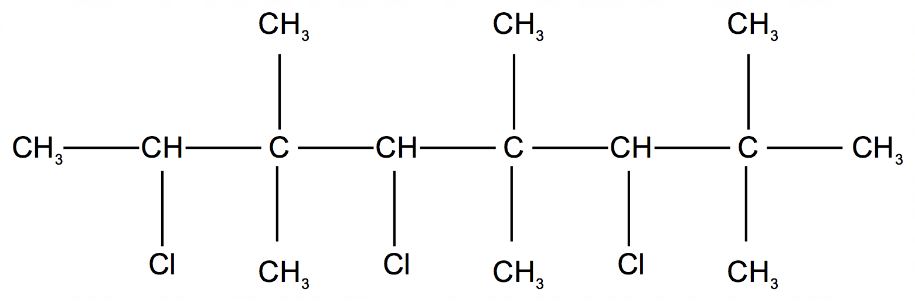

(a) 1-chloro-2,2-dimethylethene

(b) 1-chloro-but-2-ene

(c) 1-chloromethylpropene

(d) 3-chloro-2-methylbut-2-ene

24. Consider the amino acid with the structural formula below:

Which one of the following is true?

(a) A solution of the amino acid can act as a buffer.

(b) The amino acid has a lower melting point than propanoic acid.

(c) The amino acid can form an addition polymer with itself.

(d) In an acidic solution, the amino acid exists as an ion with an overall negative charge.

25. Which one of the following statements regarding ß-pleated sheets in proteins is true?

1. The ß-pleated sheets form part of the tertiary structure of proteins.
2. Hydrogen bonds are responsible for the formation of the ß-pleated sheets.
3. The ß-pleated sheet structure is created when side chains on the protein interact.

(d) A protein that contains ß-pleated sheets cannot also contain the α-helix structure.

**End of Section One**

**Section Two: Short answer 35% (70 Marks)**

**Question 26 (6 marks)**

A student investigated changes to the following equilibrium.

2 CrO42–(aq) + 2 H+(aq) reversible arrow Cr2O72–(aq) + H2O(l)

She took 50 mL of a solution of sodium dichromate/chromate and added sodium hydroxide pellets to the solution. The solution was left to return to a state of equilibrium. She then added 50 mL of distilled water to the beaker and stirred.

(a) Complete the following graph showing the changes to the concentrations of the chromate and dichromate ions involved in the reaction until a new equilibrium is reached. (4 marks)

Concentration

CrO42–

Cr2O72–(

Time

NaOH(aq) added

H2O added

|  |  |
| --- | --- |
| **Description** | **Marks** |
| correct shapes of both graphs after NaOH(aq) added | 1 |
| both graphs drop at addition of H2O | 1 |
| correct shapes of both graphs after H2O added | 1 |
| variation of CrO42– should be twice (approximately) the variation of Cr2O72– | 1 |
| **Total** | **4** |

(b) Describe the colour changes expected over the same time. (2 marks)

|  |  |
| --- | --- |
| **Description** | **Marks** |
| orange to yellow / less orange and more yellow | 1 |
| yellow solution fades (suddenly) then returns towards a deeper yellow again | 1 |
| **Total** | **2** |

Question 27 (9 marks)

In April 2017 carbon dioxide levels in the atmosphere reached 410 ppm, a level not reached for millions of years. The increase in levels of carbon dioxide is causing increased ocean acidification. Two symptoms of ocean acidification are the increase in concentration of hydrogen ions and the decrease in the concentration of carbonate ions.

(a) Using relevant equations, explain how increased levels of atmospheric carbon dioxide causes:

(i) an increase in concentration of hydrogen ions in the ocean. (2 marks)

|  |  |
| --- | --- |
| **Description** | **Marks** |
| carbon dioxide dissolves in water to form carbonic acid | 1 |
| *either:* H2O(ℓ) + CO2(g) → *or* reversible arrow H2CO3(aq)  *or:* H2CO3(aq)+ H2O(ℓ) reversible arrowHCO3– (aq)+ H3O+(aq) | 1 |
| **Total** | **2** |

(ii) a decrease in the concentration of carbonate ions. (3 marks)

|  |  |
| --- | --- |
| **Description** | **Marks** |
| The increased (level of) acidity reacts with carbonate ions | 1 |
| *either:* CO32–(aq)+ H3O+(aq) reversible arrowHCO3–(aq)+ H2O(ℓ)  *or:* CO32–(aq)+ H+(aq) reversible arrowHCO3–(aq) | 1 |
| **Total** | **2** |

(b) Explain, using a chemical equation as part of your answer, how the sustainability of coral reefs is put at risk if the concentration of carbonate ions in the ocean is reduced.

(2 marks)

|  |  |
| --- | --- |
| **Description** | **Marks** |
| coral reefs are made from calcium carbonate | 1 |
| *either:* | |
| the increased acidity reduces the concentration of carbonate ion | 1 |
| so the rate of the following reaction is reduced:  CO32–(aq)+ Ca2+(aq) reversible arrowCaCO3(s) | 1 |
| *or:* | |
| the increased acid ity dissolves the solid carbonate of the coral reef: | 1 |
| CaCO3(s) → Ca2+(aq)+ CO32–(aq) | 1 |
| **Total** | **3** |

(c) Briefly describe why a global commitment to reducing carbon dioxide gas emissions over the next few decades will slow the increase of average temperatures on surface of the Earth. (2 marks)

|  |  |
| --- | --- |
| **Description** | **Marks** |
| CO2 is a greenhouse gas/contributes to the enhanced greenhouse effect | 1 |
| agreement must be global / not just one country, as CO2 produced by many countries / affects the whole world (accept other correct answers) | 1 |
| **Total** | **2** |

Question 28 (9 marks)

The following electrochemical cell, was used to measure the standard reduction potential of aluminium. The reaction was carried out 30°C.

(a) State four (4) reasons why the measured cell reduction potential of aluminium was different than expected. (4 marks)

|  |  |
| --- | --- |
| **Description** | **Marks** |
| *Any four of:*   * hydrogen gas should be at a pressure of 100/101.3 kPa *(don’t accept just ‘wrong pressure’)* * temperature should be 25°C *(don’t accept just ‘wrong temperature’)* * zinc electrode should not be used as an inert electrode should be used / zinc will react with the HCl acid * aluminium chloride should have a concentration of 1.0 mol L-1 * salt bridge should not contain an aluminium salt as aluminium is involved in the cell reaction | 0–4 |
| **Total** | **4** |

(b) (i) On the diagram, label the anode. (1 mark)

|  |  |
| --- | --- |
| **Description** | **Marks** |
| the aluminium half-cell labelled ‘Anode’ | 1 |
| **Total** | **1** |

(ii) Using the term oxidising agent in your answer, explain your reasoning for identifying this as the anode. (2 marks)

|  |  |
| --- | --- |
| **Description** | **Marks** |
| hydrogen ions are a stronger oxidising agent than aluminium ions | 1 |
| so they (the hydrogen ions) accept electrons (to form hydrogen gas) from the aluminium / the aluminium is oxidised / aluminium loses electrons | 1 |
| **Total** | **2** |

Question 29 (11 marks)

The tertiary structure of proteins is caused by a variety of types of bonding between side groups on the amino acids that make up the protein.

(a) Draw a labelled diagram to show how dispersion forces can occur between two side chains on a protein molecule. (2 marks)

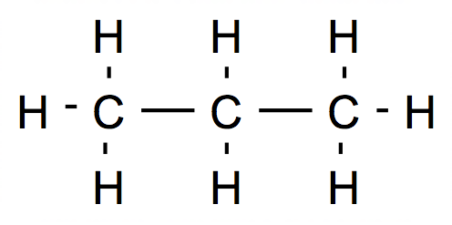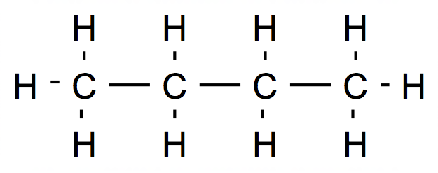

Dispersion forces

Peptide chain

|  |  |
| --- | --- |
| **Description** | **Marks** |
| non-polar chains shown aligned | 1 |
| correct position of label for dispersion forces | 1 |
| **Total** | **2** |

(b) Draw a labelled diagram to show how an ionic bonding can occur between two side chains on a protein molecule. (3 marks)

Peptide chain

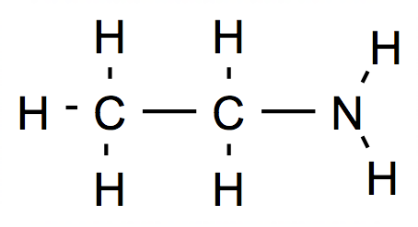

**–** H +

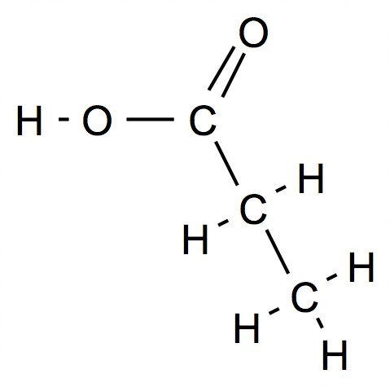

Ionic bond

**–**

|  |  |
| --- | --- |
| **Description** | **Marks** |
| suitable side chains | 1 |
| charges correctly shown on side chains | 1 |
| correct position of label for ionic bond | 1 |
| **Total** | **3** |

(c) In the case of ionic bonding in part (b), the strength of the attractions between the side groups will be dependent on the pH of the environment that the protein is in.

(i) Using your answer to part (b) above, explain why the strength of the ionic bond will be reduced if the protein was placed in a highly acidic solution.

(3 marks)



|  |  |
| --- | --- |
| **Description** | **Marks** |
| the carboxylate (anionic) group will lose its charge | 1 |
| shown by correct diagram | 1 |
| therefore no longer an ion / only dipole-dipole (or ion-dipole) forces would be present | 1 |
| **Total** | **3** |

(ii) Explain briefly why an alteration in the strength of this bonding may affect the function of the protein molecule. (3 marks)

|  |  |
| --- | --- |
| **Description** | **Marks** |
| The function of the protein molecule is (often) dependent on its tertiary structure | 1 |
| The tertiary structure of the protein is held in place by these intermolecular bonds | 1 |
| If the strength of this bonding reduces, the tertiary structure might change (thus affecting the function of the protein) | 1 |
| **Total** | **3** |

Question 30 (11 marks)

|  |  |  |  |
| --- | --- | --- | --- |
|  | **Compounds** | **Description of Test** | **Observations** |
| (a) | butan-1-ol | *either:* Add a solution of acidified potassium permanganate to both substances (and warm)  *or:* Add a solution of acidified sodium/potassium dichromate to both substances (and warm) | butan-1-ol  either: purple colour fades  or: orange solution turns (deep) green |
| methylpropan-2-ol | methylpropan-2-ol  No visible change |
| *either:* 5 CH3CH2CH2CH2OH + 4 MnO4–+ 12 H+ → 5 CH3CH2CH2COOH + 4 Mn2+ + 11 H2O  *or:* 3 CH3CH2CH2CH2OH + 2 Cr2O72–+ 16 H+ → 3 CH3CH2CH2COOH + 4 Cr3+ + 11 H2O  *or accept equations to produce the aldehyde:*  *either:* 5 CH3CH2CH2CH2OH + 2 MnO4–+ 6 H+ → 5 CH3CH2CH2CHO + 2 Mn2+ + 8 H2O  *or:* 3 CH3CH2CH2CH2OH + Cr2O72–+ 8 H+ → 3 CH3CH2CH2CHO + 2 Cr3+ + 7 H2O | | |
| (b) | a solution of methylpropan-2-ol | Add a carbonate (solid or solution) to each of the solutions. | methylpropan-2-ol  No visible change |
| a solution of propanoic acid | propanoic acid  Colourless gas produced |
|  | *either (for solid):*  2CH3CH2COOH(aq) + Na2CO3(s) → 2 Na+(aq) + 2 CH3CH2COO–(aq) + H2O(ℓ)+ CO2(aq)  *or (for solution):* CH3CH2COOH(aq) + CO32–(aq) → CH3CH2COO–(aq) + H2O(ℓ) + CO2(g) | | |

|  |  |
| --- | --- |
| **Description** | **Marks** |
| (a) |  |
| correct test chosen | 1 |
| correct positive test observation | 1 |
| correct negative test observation | 1 |
| correct half equations | 2 |
| equation balanced | 1 |
| (b) |  |
| correct test chosen | 1 |
| correct positive test observation | 1 |
| correct negative test observation | 1 |
| correct equation | 1 |
| correct state symbols | 1 |
| **Total** | **11** |

Question 31 (6 marks)

Write observations for the changes occurring when the substances below are mixed. In your answers include the appearance of the reactants and any product(s) that form.

If no change is observed, you should state this.

(a) Solid iodine is added to a solution of potassium chloride. (2 marks)

|  |  |
| --- | --- |
| **Description** | **Marks** |
| Grey/purple solid is added to clear colourless solution. No change | 2 |
| **Total** | **2** |

(b) Iron(III) chloride solution is added to solid copper. (2 marks)

|  |  |
| --- | --- |
| **Description** | **Marks** |
| Salmon pink solid added to pale brown solution | 1 |
| Solution turns to pale green / blue (accept green/blue) | 1 |
| **Total** | **2** |

(c) Ethene gas is bubbled through a solution of aqueous bromine. (2 marks)

|  |  |
| --- | --- |
| **Description** | **Marks** |
| Clear colourless gas bubbled through orange solution | 1 |
| Solution turns colourless | 1 |
| **Total** | **2** |

Question 32 (11 marks)

(a) 20.0 mL of 0.0400 mol L-1 hydrochloric acid solution was added to 45.0 mL

0.0200 mol L-1 of sodium hydroxide solution. Calculate the pH of the resulting solution. (5 marks)

|  |  |
| --- | --- |
| **Description** | **Marks** |
| n(H+) = 0.0400 x 0.020 = 8.00 x 10-4 mol  n(OH–) = 0.0200 x 0.0450 = 9.00 x 10-4 mol | 1 |
| n(OH–)excess = 9.00 x 10-4– 8.00 x 10-4 = 1.00 x 10-4 mol | 1 |
| [OH–]resulting = 1.00 x 10-4/ 0.065 = 0.001538461 mol L-1 | 1 |
| [H+] = 1.00 x 10-14/ 0.001538 = 6.5 x 10-12 mol L-1 | 1 |
| pH = -log(6.5 x 10-12)  **= 11.2** | 1 |
| **Total** | **5** |

(b) The experiment in (a) was repeated, but this time using 20.0 mL of 0.0400 mol L-1 ethanoic (acetic) acid solution instead of the hydrochloric acid. Would the pH of the final solution be the same or different from the answer calculated in part (a)? Explain your reasoning (no calculations are required). (3 marks)

|  |  |
| --- | --- |
| **Description** | **Marks** |
| the same | 1 |
| the ethanoic acid will totally ionise due to the presence of the strong base, NaOH | 1 |
| therefore, the number of moles of hydrogen/ hydronium ions provided to the solution will be the same | 1 |
| *Xs OH- so no H+ for ethanoate to gain* |  |
| **Total** | **3** |

(c) The experiment in (a) was repeated again, but this time using 20.0 mL of

0.0400 mol L-1 sulfuric acid solution instead of the hydrochloric acid. Would the pH of the final solution be the same or different from the answer calculated in part (a)? Explain your reasoning. (3 marks)

|  |  |
| --- | --- |
| **Description** | **Marks** |
| different | 1 |
| sulfuric acid is a diprotic acid | 1 |
| so the number of moles of hydrogen/hydronium ions provided to the solution will be more / there will be an excess of hydrogen/ hydronium ions | 1 |
| **Total** | **3** |

Question 33 (9 marks)

Carbon disulfide (CS2) can be manufactured using an endothermic reaction between sulfur trioxide gas and carbon dioxide as shown below:

2 SO3(g) + CO2(g) reversible arrow CS2(g) + 4 O2(g)

(a) Write an expression for the equilibrium constant of the reaction. (1 mark)

|  |  |
| --- | --- |
| **Description** | **Marks** |
| K = [CS2][O2]4  [SO3]2[CO2] | 1 |
| **Total** | **1** |

(b) Predict how each of the following changes to an equilibrium mixture would affect the yield of CS2. (increase, decrease or no effect)

(i) addition of CO2 (at constant total volume) (1 mark)

|  |  |
| --- | --- |
| **Description** | **Marks** |
| increase | 1 |
| **Total** | **1** |

(ii) increasing the temperature (1 mark)

|  |  |
| --- | --- |
| **Description** | **Marks** |
| increase | 1 |
| **Total** | **1** |

(iii) adding a catalyst (1 mark)

|  |  |
| --- | --- |
| **Description** | **Marks** |
| no change | 1 |
| **Total** | **1** |

(iv) increasing the overall pressure by introducing argon gas into the reaction vessel (at constant volume) (1 mark)

|  |  |
| --- | --- |
| **Description** | **Marks** |
| no change | 1 |
| **Total** | **1** |

(c) In the production plant, the carbon disulfide is removed from the reaction vessel on a regular basis. Using collision theory, explain how this technique will increase the yield of the reaction. (4 marks)

|  |  |
| --- | --- |
| **Description** | **Marks** |
| the concentration of the carbon disulfide is reduced | 1 |
| this reduces the rate of the reverse reaction due to less collisions | 1 |
| the rate of the forward reaction is not initially affected | 1 |
| therefore there is a ‘net forward reaction’ / the forward reaction is favoured/ products are favoured relative to the reverse reaction / the equilibrium shifts to the right | 1 |
| **Total** | **4** |

**End of Section Two**

**This page has been left blank intentionally**

**Section Three: Extended answer 40% (80 marks)**

This section contains five (**5)** questions. You must answer **all** questions. Write your answers in the spaces provided.

Where questions require an explanation and/or description, marks are awarded for the relevant chemical content and also for coherence and clarity of expression. Lists or dot points are unlikely to gain full marks.

Final answers to calculations should be expressed to the **appropriate number** of significant figures.

Additional working space pages at the end of this Question/Answer booklet are for planning or continuing an answer. If you use these pages for planning, indicate at the original answer, the page number it is planned/continued on and write the question number being planned/continued on the additional working space page.

Suggested working time: 70 minutes*.*

Question 34 (19 marks)

The opening of Perth Children’s hospital has been delayed due to lead contamination of the drinking water. Lead is a neurotoxin that is particularly harmful to children. One of the possible causes of the contamination was brass fittings. Brass is a [metal](https://en.wikipedia.org/wiki/Metal) [alloy](https://en.wikipedia.org/wiki/Alloy) made of copper and zinc but lead is sometimes added to improve its malleability.

A recent large-scale study on water samples in New South Wales found that low-level lead contamination of water is widespread in Australian homes, with brass tap fittings the most likely source. In a subsequent experiment, the researchers tested water before and after it passed through brass taps and stainless-steel taps. Lead was only found in water that had passed through brass ones.

In 2014, the US government mandated a lead limit of 0.25 percent in plumbing fittings.

Taps in Australia are typically made of brass that contains lead at a level of about 2 to 4 percent.

(a) Use evidence from the list of standard reduction potentials on your data sheet to explain why lead from brass is more likely than copper to corrode into drinking water. (2 marks)

|  |  |
| --- | --- |
| **Description** | **Marks** |
| the (standard) reduction potential for Pb2+/Pb is –0.13 V and for Cu2+/Cu +0.34 V | 1 |
| which makes lead metal a stronger reducing agent than copper metal / lead oxidises more readily than copper | 1 |
| **Total** | **2** |

(b) Write an ionic equation, including state symbols, for the reaction of sulfuric acid with metallic lead. (2 marks)

Pb(s) + 2 H+(aq) + SO4 2-(aq) → PbSO4(s) + H2(g)

|  |  |
| --- | --- |
| **Description** | **Marks** |
| correct ionic equation (maximum 1 mark out of 2 if not ionic) | 1 |
| correct state symbols | 1 |
| **Total** | **2** |

(c) In the experiment described in the passage above, identify the independent and dependent variable. (2 marks)

|  |  |
| --- | --- |
| **Description** | **Marks** |
| independent variable = material used to make tap | 1 |
| dependent variable = level/concentration/amount of lead in water | 1 |
| **Total** | **2** |

An experiment was carried out to calculate the percentage of lead in a sample of brass. A

45.13 g sample of brass was dissolved in excess 6.00 mol L-1 hydrochloric acid and any non-metallic insoluble solids were filtered out. Then an excess of 0.500 mol L-1 sodium sulfate solution was added to precipitate lead(II) sulfate. After washing and drying, this precipitate was had a mass of 2.33 g.

(d) (i) Calculate the percentage by mass of lead in the sample. (5 marks)

|  |  |
| --- | --- |
| **Description** | **Marks** |
| n(PbSO4) = m / M = 2.33 / 303.27 = 7.683 × 10-3 mol | 1 |
| n(Pb) = 7.683 × 10-3 mol | 1 |
| m(Pb) = n × M = 7.683 × 10-3 × 207.2 = 1.592 g | 1 |
| %(Pb) = (1.592 / 45.13) x 100 = **3.53%** | 1 |
| *answer to three significant figures* | 1 |
| **Total** | **5** |

(ii) Write an ionic equation, including state symbols, for the precipitation reaction used in this experiment and calculate the minimum volume (in mL) of the

0.500 mol L-1 sodium sulfate solution required. (4 marks)

|  |  |
| --- | --- |
| **Description** | **Marks** |
| SO42-(aq) + Pb2+(aq) → PbSO4(s) | 1 |
| n(PbSO4) = n(Pb) = 7.683 × 10-3 mol | 1 |
| v(PbSO4) = n/c = 7.683 × 10-3 / 0.500 = 0.0154 | 1 |
| **= 15.4 mL** | 1 |
| **Total** | **4** |

Lead acts as a poison by displacing biologically-active metal cations, such as calcium and zinc, from their proteins that act as enzymes. Calmodulin, for example is an enzyme that regulates a number of body functions, including muscle contraction, metabolism and memory. Lead displaces one calcium atom from the enzyme molecule, thus reducing the enzyme’s efficiency.

(e) Briefly describe how the enzymes catalyse chemical reactions occurring in the body. (2 marks)

|  |  |
| --- | --- |
| **Description** | **Marks** |
| provide an alternative reaction pathway | 1 |
| with a lower activation energy *(accept ‘lowers the activation energy of the chemical reaction’ for 2 marks)* | 1 |
| **Total** | **2** |

(f) Using evidence from the periodic table, suggest why the replacement of calcium in an enzyme molecule by lead will significantly affect the function of the enzyme.

(2 marks)

|  |  |
| --- | --- |
| **Description** | **Marks** |
| *either:* | |
| the lead atom/ion is significant larger/heavier than the calcium atom/ion | 1 |
| so the structure of the protein/enzyme will be distorted/altered | 1 |
| *or:* | |
| the lead atom has four valence electrons compared to calcium that has two valence electrons | 1 |
| therefore the bonding/structure within the protein/enzyme will be changed *(accept other sensible answers if they are based on a comparison of the properties of lead and calcium atoms or ions)* | 1 |
| **Total** | **2** |

Question 35 (15 marks)

A diprotic amino acid, known to only contain carbon, hydrogen, oxygen and nitrogen underwent analysis to determine its formula. When a 12.50 g sample of the amino acid was combusted in oxygen, 18.69 g of carbon dioxide, 6.89 g of water, and 3.91 g of nitrogen dioxide was produced.

2.27 g of the acid was dissolved in 50.0 mL of water. 10.0 mL of this solution required

24.70 mL of 0.0250 mol L-1 sodium hydroxide solution for complete neutralisation.

(a) Calculate the empirical formula of the amino acid. (7 marks)

|  |  |  |  |  |  |
| --- | --- | --- | --- | --- | --- |
| m(C) = 18.69 × (12.01/44.01) = 5.100 g | | | | | 1 |
| m(H) = 6.89 × (2.016/18.016) = 0.771 g | | | | | 1 |
| m(N) = 3.91 × (14.01/46.01) = 1.190 g | | | | | 1 |
| Oxygen | | | | | |
| m(O) = 12.50 – 5.100 – 0.771 – 1.190 = 5.438 g | | | | | 1 |
|  | **C** | **H** | **N** | **O** |  |
| mass (g) | 5.100 | 0.771 | 1.190 | 5.438 |
| mole ratio | 5.100/12.01 | 0.771/1.008 | 1.190/14.01 | 5.438/16.00 |  |
|  | 0.425 | 0.765 | 0.0849 | 0.340 | 1 |
| divide by smallest | 0.425 / 0.0849 | 0.765 / 0.0849 | 0.0849 / 0.0849 | 0.340 / 0.0849 |  |
|  | 5.00 | 9.00 | 1 | 4.00 | 1 |
| **Empirical Formula** | **C5H9NO4** | | | | 1 |
| **Total** | | | | | **7** |

(b) Calculate the molecular mass of the amino acid. (4 marks)

|  |  |
| --- | --- |
| **Description** | **Marks** |
| n(NaOH)in 10 mL = 0.250 x 0.02470 = 0.006175 mol | 1 |
| n(NaOH)in 50 mL = 0.006175 x (50.0/10) = 0.03087 mol | 1 |
| n(diprotic amino acid)= (1/2) x n(NaOH) = 0.01544 mol | 1 |
| M((diprotic amino acid) = m/n = 2.27 / 0.01544 = 147.0 = 147 | 1 |
| **Total** | **4** |

(c) Use your data booklet to name the amino acid. (1 mark)

|  |  |
| --- | --- |
| **Description** | **Marks** |
| glutamic acid | 1 |
| **Total** | **1** |

*Note: If you were unable to determine an answer to part (c), use aspartic acid for the remainder of this question*

(d) Draw the structure of the amino acid that would exist in a solution with a pH of 10.

(1 mark)

|  |  |
| --- | --- |
| **Description** | **Marks** |
| –  (need to have negative charges on both carboxylate groups) | 1 |
| **Total** | **1** |

(e) Write an equation, using structural formulae, for the reaction between the amino acid and glycine to form a dipeptide. (2 marks)





+ H2O

→

+

|  |  |
| --- | --- |
| **Description** | **Marks** |
| correct species | 1 |
| balanced with the one water molecule | 1 |
| **Total** | **2** |

Question 36 (14 marks)

The reaction for the production of ethanol from ethene is shown below.

CH2CH2(g) + H2O(g) reversible arrow CH3CH2OH(g) ∆H = -45 kJ mol–1

(a) Use green chemistry principles to explain why it is beneficial to achieve a high yield of ethanol. (2 marks)

|  |  |
| --- | --- |
| **Description** | **Marks** |
| by achieving a high yield there are less wasted reactants | 1 |
| Any one of:   * saves money * more sustainable use of resources * less disposal issues   *(do not accept just ‘better for the environment’)* | 1 |
| **Total** | **2** |

(b) Use sustainability principles to explain why it may be beneficial to source ethanol through a fermentation process rather than the reaction shown above. (2 marks)

|  |  |
| --- | --- |
| **Description** | **Marks** |
| fermentation uses biomass to produce ethanol | 1 |
| biomass is renewable whereas ethene is sourced from non-renewable crude oil | 1 |
| **Total** | **2** |

(c) It was found that 170.8 kg of ethanol was produced from 200.0 kg of ethene gas. Calculate the percentage yield of this reaction. (4 marks)

|  |  |
| --- | --- |
| **Description** | **Marks** |
| n(CH2CH2) = 200 000 / 28.052 = 7 129 mol | 1 |
| n(CH3CH2OH)expected = n(CH2CH2) = 7 129 mol | 1 |
| m(CH3CH2OH)expected = 7129 x 46.068 = 328 447 g | 1 |
| % yield = (170800 / 328447) x 100 = 52.00 % | 1 |
| **Total** | **4** |

The ethanol in this reaction can be used to make ethyl ethanoate.

(d) Write an equation for this reaction, and state the conditions required. (2 marks)

|  |  |
| --- | --- |
| **Description** | **Marks** |
| CH3CH2OH + CH3COOH → CH3COOCH2CH3 + H2O | 1 |
| (sulfuric) acid catalyst | 1 |
| **Total** | **2** |

(e) If this reaction has a yield (efficiency) of 67.0%, calculate the mass of ethanol required to produce 1.00 tonne (1.00 x 106 g) of the ethyl ethanoate. (4 marks)

|  |  |
| --- | --- |
| **Description** | **Marks** |
| n(CH3COOCH2CH3) = 1.00 x 106/ 88.104 = 11350 mol | 1 |
| n(CH3CH2OH)requiired = (1/1) x (100/67.0) x 11350 mol = 16941 mol | 1 |
| n(CH3CH2OH)requiired = 16941 x 46.068 = 780 421 g = 780 kg | 1 |
| three significant figures used | 1 |
| **Total** | **4** |

**This page has been left blank intentionally**

**Question 37 (20 marks)**

A team of students competing in a competition to test their titration skills were tasked with using a standard solution of 0.1023 mol L-1 hydrochloric acid to standardise a solution of sodium hydroxide. They then had to use this sodium hydroxide solution to determine the concentration of a solution of acetic (ethanoic) acid, CH3COOH.

They were provided with two indicators, whose names and pH ranges are given below.

|  |  |  |  |
| --- | --- | --- | --- |
| **Indicator** | **Acid colour** | **pH range of colour change** | **Base colour** |
| Phenolphthalein | colourless | 8.2 – 10.0 | deep pink |
| Methyl Red | red | 4.8 – 6.0 | yellow |

The students placed the sodium hydroxide solution in the burette for both titrations and used methyl red indicator for the standardisation of the sodium hydroxide and phenolphthalein for the standardisation of the acetic acid.

They found that an average of 23.55 mL of sodium hydroxide solution was required to neutralise 20.00 mL of the 0.1023 mol L-1 hydrochloric acid.

(a) Calculate the concentration of the sodium hydroxide solution. (3 marks)

|  |  |
| --- | --- |
| **Description** | **Marks** |
| n(HCl) = c × V = 0.1023 × 0.0200 = 0.002046mol | 1 |
| n(NaOH) = 0.002046mol | 1 |
| c(NaOH) = 0.002046 / 0.02355 **= 0.0869 mol L-1** | 1 |
| **Total** | **3** |

They then titrated the sodium hydroxide against 25.00 mL of the acetic acid and obtained the following results, using phenolphthalein as the indicator.

|  |  |  |  |  |
| --- | --- | --- | --- | --- |
| **Volume of sodium hydroxide** | **Titrations** | | | |
| 1 | 2 | 3 | 4 |
| Final Reading (mL) | 17.70 | 35.15 | 19.45 | 36.85 |
| Initial Reading (mL) | 0.00 | 17.70 | 2.00 | 19.45 |
| Titre (mL) | **17.70** | **17.45** | **17.45** | **17.40** |

(b) Complete the table and calculate the concentration of the acetic acid solution

*Note: if you were unable to calculate the concentration of the sodium hydroxide solution in part (a), use a concentration of 0.1032 mol L-1 for the rest of this question.*

(i) in moles per litre. (4 marks)

|  |  |
| --- | --- |
| **Description** | **Marks** |
| V(NaOH)average = (17.45 + 17.45 + 17.40)/3 = 17.43 mL  = 0.01743 L | 1 |
| n(NaOH) = 0.0869 x0.01743 = 0.0015143 mol | 1 |
| n(CH3COOH) = (1/1) x n(NaOH) = 0.0015143 mol | 1 |
| c(CH3COOH) = 0.001515 / 0.02500 = **0.0606 mol L-1** | 1 |
| **Total** | **4** |

*Alternative calculation using given value for c(NaOH) of 0.1032 mol L-1:*

|  |  |
| --- | --- |
| **Description** | **Marks** |
| V(NaOH)average = (17.45 + 17.45 + 17.40)/3 = 17.43 mL  = 0.01743 L | 1 |
| n(NaOH) = 0.1032 x0.01743 = 0.001799 mol | 1 |
| n(CH3COOH) = (1/1) x n(NaOH) = 0.001799 mol | 1 |
| c(CH3COOH) = 0.001799 / 0.02500 = **0.0720 mol L-1** | 1 |
| **Total** | **4** |

(ii) as a percentage by mass (assume mass of 25.0 mL sample = 25.0 g)

(3 marks)

|  |  |
| --- | --- |
| **Description** | **Marks** |
| n(CH3COOH)in 1.00 L = 0.0606 mol | 1 |
| m(CH3COOH)in 1.00 L = 0.0606 x 60.052 = 3.64 g | 1 |
| %(CH3COOH)by mass = (3.64 / 1000) x 100 **= 0.364%** | 1 |
| **Total** | **3** |

*Alternative calculation using given value for c(NaOH):*

|  |  |
| --- | --- |
| **Description** | **Marks** |
| n(CH3COOH)in 1.00 L = 0.0720 mol | 1 |
| m(CH3COOH)in 1.00 L = 0.0720 x 60.052 = 4.32 g | 1 |
| %(CH3COOH)by mass = (4.32 / 1000) x 100 **= 0.431%** | 1 |
| **Total** | **3** |

(c) Describe, including quantities of chemicals, how the method of the experiment can be revised to ensure that the volumes of the titres of sodium hydroxide from the burette are approximately 20.00 mL, thus giving more accurate results. (4 marks)

|  |  |
| --- | --- |
| **Description** | **Marks** |
| aiming for v(NaOH) = 20.00 mL so need to dilute the NaOH solution by a factor of 20.0/4.15 ≈ 4.8 ≈ 5 | 1 |
| pipette 20.00 mL of the 0.0869 mol L-1 NaOH solution | 1 |
| and make it up to 100 mL in a volumetric flask (or equivalent volumes to perform the same dilution – but must mention correct equipment) | 1 |
| use this diluted NaOH solution to titrate against the second sample of acetic acid | 1 |
| **Total** | **4** |

(d) Another, less well coached team, used the indicators the wrong way, with phenolphthalein indicator for the standardisation of the sodium hydroxide and methyl red for the standardisation of the acetic acid. Explain detail how this error would affect their results. You can use sketches of graphs in your response. (6 marks)

|  |  |
| --- | --- |
| **Description** | **Marks** |
| The first titration of the sodium hydroxide and hydrochloric acid is between a strong acid and a strong base. | 1 |
| So the phenolphthalein will still change colour close to the equivalence point. (can be shown on titration curve)  12  7  1  End point for phenolphthalein indicator  pH  Volume of NaOH added | 1 |
| Therefore this will lead to small amount of (systematic) error in the concentration of the concentration of the sodium hydroxide solution. (higher volume recorded so calculated concentration will be lower than actual value) | 1 |
| The second titration of the sodium hydroxide and ethanoic acid is between a weak acid and a strong base so the equivalence point will be basic. | 1 |
| So the end point will be significantly different from the equivalence point. (can be shown on titration curve)  12  7  1  End point for methyl red indicator  pH  Volume of NaOH added | 1 |
| The volume recorded for the NaOH will be significantly less than the correct reading and therefore the calculated concentration of the sodium hydroxide will be much higher than the actual value. | **1** |
| **Total** | **6** |

**This page has been left blank intentionally**

Question 38 (12 marks)

The following diagram represents a phosphoric acid fuel cell. These cells operate at temperatures between 150–200°C and are used as backup power and energy supply for places like banks and hospitals.

–

+

Hydrogen gas

Oxygen gas in

Excess hydrogen gas out

Excess Oxygen and hot water

(and steam) out

Porous carbon- platinum electrodes

Electrolyte (liquid H3PO4 in a silicon carbide ceramic matrix)

### 

The half-equations for this cell are:

Anode: H2(g) → 2 H+(aq) + 2 e–

Cathode: O2(g) + 4 H+(aq) + 4 e– → 2 H2O(ℓ and g)

(a) Examine the diagram and:

(i) describe the specific role of the phosphoric acid in this cell. (2 marks)

|  |  |
| --- | --- |
| **Description** | **Marks** |
| to allow the flow of hydrogen ions | 1 |
| from the anode to the cathode | 1 |
| **Total** | **2** |

(ii) explain why the porous nature of the electrode aids the process occurring at the anode. (2 marks)

|  |  |
| --- | --- |
| **Description** | **Marks** |
| to increase the surface area of the electrode | 1 |
| to allow the hydrogen gas maximum contact with the electrode / external circuit | 1 |
| **Total** | **2** |

(iii) suggest specifically why the high temperature is used in this cell. (1 marks)

|  |  |
| --- | --- |
| **Description** | **Marks** |
| to increase the conductivity of the (liquid) phosphoric acid OR the heated water (and steam) produced is used for heating in the buildings i.e. at 150-200 oC of the cell produces heated and vapourised water that can be used OR increases the rate of charge flow | 1 |
| **Total** | **1** |

(b) Write the overall redox reaction from the fuel cell and describe one advantage and one disadvantage of the use of the fuel cell directly related to this equation. (3 marks)

|  |  |
| --- | --- |
| **Description** | **Marks** |
| 2 H2(g) + O2(g) → 2 H2O(l) | 1 |
| Advantage:  the only product of the cell is water (which is a safe substance) | 1 |
| Disadvantage:  hydrogen and oxygen need to be continuously supplied to the cell | 1 |
| **Total** | **3** |

(c) The hydrogen used in for fuel cells can be synthesised using a range of reactions. One example is the endothermic dehydrogenation of methyl cyclohexane into methylbenzene (toluene) shown below. To maximise the yield the reaction occurs at a high pressure and temperature.

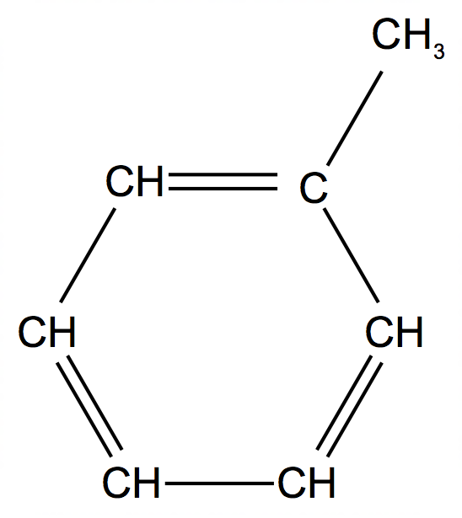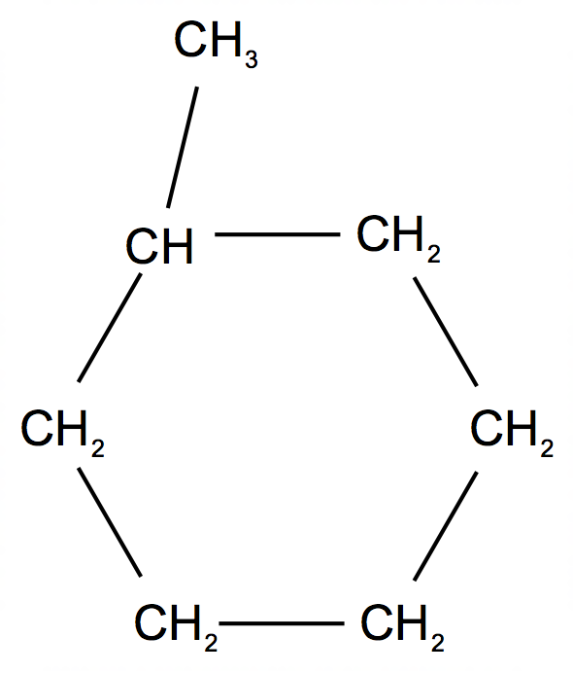

+ 3 H2(g)

reversible arrow

Assuming an 80.0% yield for this reaction, calculate the volume of hydrogen gas at 500°C and 650 kPa produced for every 1000 g of methyl cyclohexane. (4 marks)

|  |  |
| --- | --- |
| **Description** | **Marks** |
| n(C7H14) = 1000 / 98.182 = 10.185 mol | 1 |
| n(H2) = (80/100) x (3/1) x n(C7H14) = (80/100) x (3/1) x 10.185  = 24.44 mol | 1 |
| PV=nRT  V = nRT/P = (24.44 x 8.314 x 773.15) / 650 | 1 |
| **= 242 L** | 1 |
| **Total** | **4** |

**End of questions**